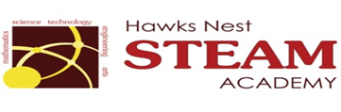School Counseling Program Newsletter
Shandrai Silva, School Counselor | February 2019

Counselor Message  Welcome to February. The school counseling program is gearing up for another great semester at Hawks Nest.  In January, the school counseling program continued with classroom guidance lessons, small group counseling and individual meetings with students. We recognized No Name- Calling Week which included Student Council creating a video about name-calling share with our student body. We also participated in the Great Kindness Challenge Week. We participated in Five Days of Kindness, performing a kind act a day as school We wore yellow on Jan. 31st. Student Council in collaboration with our first grade students led a Kindness Pep Rally.  More great times await us!  ____________________________  How to see the school counselor  Classroom guidance classes are weekly based on grade level specials schedule. Small group counseling and individual counseling by self -referral, parent referral, teacher referral, administrator referral or counselor initiated.  Contact School Counselor at 704-866-8467or sosilva@gaston.k12.nc.us.   | Home of the Hawks     February 4 - 8, 2019  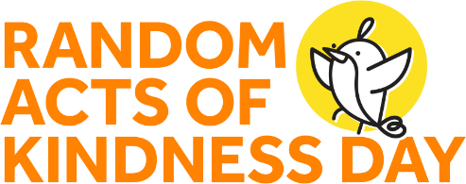  RAK Day is February 17, 2019 #KINDNESSSTARTSWITHONE  https://www.randomactsofkindness.org/rak-day    February 2019 | Character Education  “We’re Soaring with Good Character”  ______________________________  The character trait of the month is Self-discipline. Self-discipline means being responsible for your actions; being in charge of the things you say and do and making choices that are healthy, safe, kind and respectful to others.  __________________________________  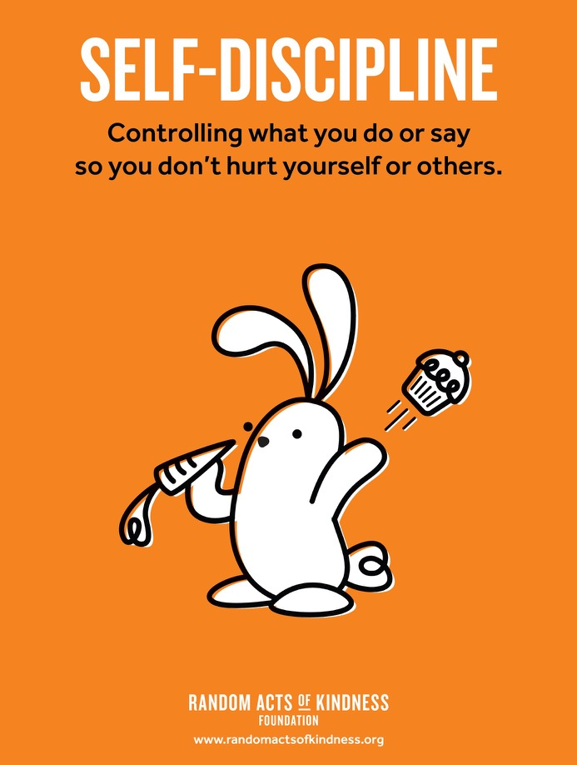  “Intelligence plus character- that is  the goal of true education.”  Dr. Martin L. King, Jr.  

